

Smart Summer School Report

Done by: Alaa Yehia 6432

Ali Jaafar 6411

Presented to: Dr. Mohammad Aoude

# Abstract

The Summer School Manager Platform is a full-stack web application designed to assist students in effectively managing their summer academic activities. It empowers users to explore available classes, browse teacher profiles, track academic announcements, and interact with an AI-powered assistant. The platform combines a user-friendly interface with intelligent backend services, offering features such as course pathway recommendations and conversational support via a locally deployed LLaMA 3 language model.

**Table of Contents**

Abstract 2

Objective 3

Project Development 3

System Architecture 3

Technologies Used 4

Key Features 4

Conclusion 6

**Table of Figures**

Figure 1 Student Dashboard 5

Figure 2 Ai Assistant tab 5

Figure 3 Rule Based Course Pathway AI 5

Figure 4 Chat AI Assistant 5

# Objective

The primary goal of this project is to build a centralized platform that simplifies the summer school experience for students. The system aims to:  
- Present available classes with structured metadata such as difficulty level and learning outcomes.  
- Allow students to browse teacher availability and expertise.  
- Display important institutional announcements with their relevance.  
- Recommend tailored course pathways based on student preferences.  
- Enable chatbot interaction through a local LLM (LLaMA 3) for personalized assistance.

# Project Development

## System Architecture

The platform follows a modular full-stack architecture composed of:

* Frontend: Developed in React.js, the UI contains five main tabs:
  + Dashboard – shows current enrolled classes, available ones, announcements, and teacher overview.
  + Courses – provides a detailed catalog of available classes, their topics, and learning outcomes.
  + Teachers – showcases profiles with professional experience and current availability.
  + Announcements – delivers key news and updates with prioritization.
  + AI Assistant – includes a multi-step course recommender and a chat interface backed by LLaMA 3.
* Backend: Built with Node.js + Express, the backend exposes RESTful API endpoints to serve class, teacher, and announcement data from the database.
  + Database: A PostgreSQL instance manages structured data.
  + LLM Integration: The AI Assistant includes a rule-based recommender and chat assistant using MiniLLaMA 3.

## Technologies Used

|  |  |
| --- | --- |
| Layer | Tech Stack |
| Frontend | React.js |
| Backend | Node.js, Express.js |
| Database | PostgreSQL |
| LLM | LLaMA 3 (Ollama) |
| Container | Docker Compose |

# Key Features

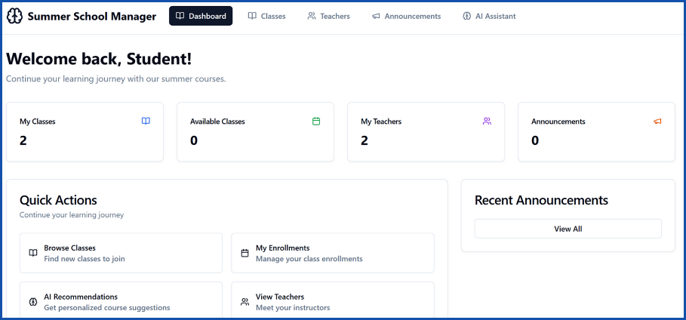1. Dashboard – Overview of classes, teachers, and announcements.  
2. Course Catalog – Detailed view of courses with metadata and filters.  
3. Teacher Profiles – Includes expertise and availability.  
4. Announcements – Sorted by importance and category.  
5. AI Assistant – Rule-based form and LLaMA 3 chatbot.

Figure Student Dashboard

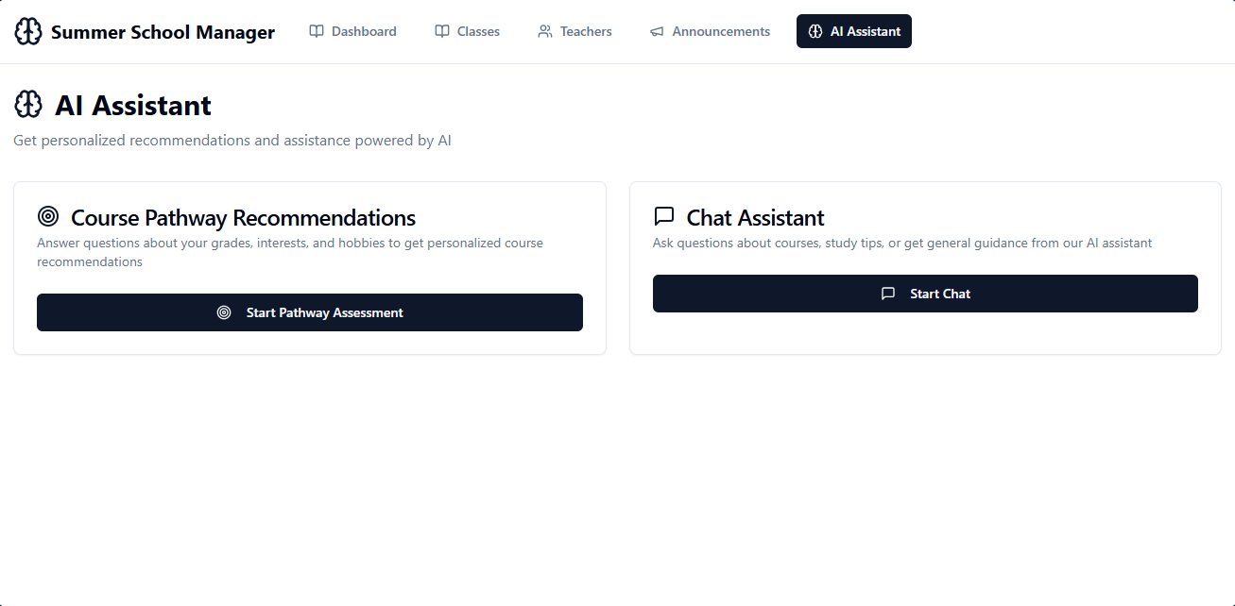

Figure Ai Assistant tab

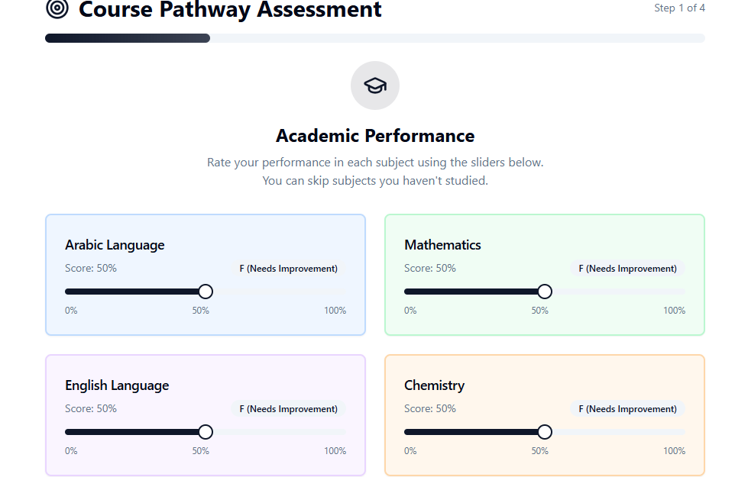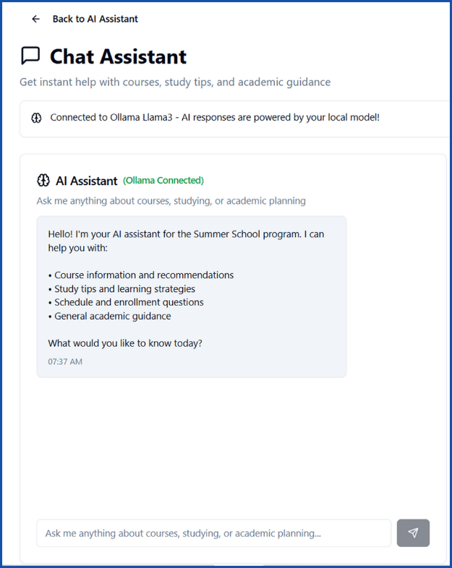

Figure Rule Based Course Pathway AI

Figure Chat AI Assistant

# Conclusion

This project showcases how modern full-stack development, combined with local LLM deployment, can enhance educational services. The Summer School Manager System integrates data management, intelligent user assistance, and seamless UI/UX to support students in navigating their summer coursework. Its modular, Dockerized setup allows for easy deployment and sharing. Future improvements could include a user login system, calendar integration, and more dynamic AI logic powered by fine-tuned models.